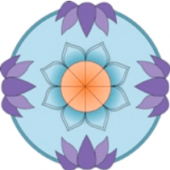
sakyadhita

19th international conference on buddhist women
kuching, sarawak | june 15 to 23, 2025

“Navigating Change: Buddhist Women in Transition”

CALL FOR WORKSHOPS

Sakyadhita invites proposals for workshops to be presented at the 19th Sakyadhita Conference in Kuching, Sarawak, next summer. Workshops should be interactive, engaging participants in dialogue, discussion, movement, or some similar activity. Proposals should be 250–500 words in length, including an introduction and an explanation of how you plan to organize your workshop.

Select a topic that will engage a broad audience, beyond one specific center, project, or monastery. Proposals promoting a specific teacher, tradition, or project are not likely to be selected. You may submit more than one workshop proposal.

Most workshops are limited to 20 to 30 people to facilitate an exchange of ideas and experiences. Meditation workshops may be larger. Please inducate how much space you will need for your workshop.

Workshops can be as long as 2 hours. Most begin with an icebreaker, so participants can get to know each other. Workshops do not require a written paper, just an outline of how you plan to facilitate your workshop.

Send proposal to: sarawak2025@gmail.com.
Deadline for submission: January 20, 2025.

